
WrapStyle Cairo – Empyrean Enterprises

Cloud Nine Mall, Mohamed Naguib Axis, New Cairo
Cairo, Egypt
+2012 00 999 333
Saturday, March 28, 2026 – 3:39 PM

Job Order
Job Order | #2603282327 تعديل
Branch | ☒ New Cairo – ☐ Zayed
Customer Name | Marwan Omar
Customer Phone Number
Car Color, Make & Model | Mercedes GLC 43 - Nardo Grey
Services  PPF Full pkg (66,000)  Window film (16,000)  2 screens protector (6,000)  Total: (88,000)  Discount:(5,000)  Total After Discount:(83,000) | Paint Protection Film:  ☒ Full Wrap Excluding Roof – ☐ Full Wrap Including Roof  ☐ Hood – ☐ Trunk – ☐ Front Bumper – ☐ Rear Bumper  ☐ Right Front Fender – ☐ Left Front Fender  ☐ Right Rear Fender – ☐ Right Left Fender  ☐ Front Right Door – ☐ Front Left Door – ☐ Rear Right Door – ☐ Rear Left Door  ☐ Other:  Thermal Insulation Window Film:  ☐ Full – ☐ Front Half – ☐ Rear Half – ☐ Front Doors – ☐ Rear Doors  ☐ Front Windshield – ☐ Rear Windshield - ☐ Other:  Vinyl Color Wrap:  ☐ Full – ☐ Other  Color:  ☐ Windshield Protection: ☐ Plexi – ☐ Plexi Plus  ☐ Car Screen Protection:  ☒ 1 Screen – ☐ 2 Screens – ☐ 3 Screens – ☐ 4 Screens – ☐ 5 Screens  ☐ Exterior Detailing:  ☐ Removable Paint:
Remarks:

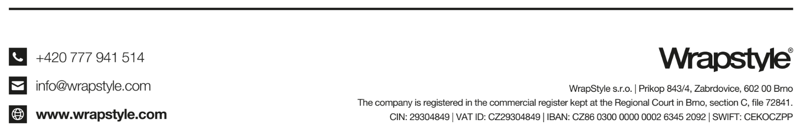

Issued by: Elaf Waleed Customer Signature:
+2012 00 999 333
cairo@wrapstyle.com
Empyrean Enterprises
Mohamed Naguib Axis, Cloud 9 Mall, New Cairo, Egypt
Tax ID: 555-579-042

Terms & Conditions: All above prices are inclusive of 14% value added tax (VAT). By signing this form, the customer has agreed to the above price, understands the warranty extended to installed products and confirms that all belongings have been removed from the vehicle. The company is not responsible for any damage to the vehicle’s paint in case of poor-quality paintwork regardless of this being original factory paintwork or not. The wrapping of recently painted body parts may result in damage to the paint. The customer agrees to full payment of the above price before receiving the vehicle. The company is not responsible for battery damage. The customer is agreeing to uninstalling car parts necessary to the installation process unless requested otherwise.

